**Relationship between energy consumption and CO2 emission per metric ton**

**Student Name: Sherin Dorothy Bakkiaraj**

**Student ID: 21032279**

**Github link:** <https://github.com/29-sherin/Climate-Change-.git>

**Abstract:**

**In this document, we are going to discuss about Co2 emissions metric ton per capita and Energy use (kg of equivalent)per capita.**

**Co2 emissions are human made.** Humans emitted more than 35 billion tons of carbon dioxide (CO2) into the atmosphere by burning fossil fuels. It can be difficult to picture a “ton” of a gas like CO2, so let’s describe it in a few different ways.

**Electric power consumption per capita (kWh ) is the production of power plants and combined heat and power plants less transmission, distribution, and transformation losses and own use by heat and power plants, divided by midyear population.**

**Usingb these datasets we gonna find the relationship between energy consumption and Co2 Emission per metric ton.**

**Relationship between energy consumption and CO2 emission per metric ton**

**In this analysis we used 5 countries to analyze carbon IV oxide emission metric tons per capita in a year and Energy used per capita in each of the countries. We believe there is a great correlation between energy utilization and emission of Carbon IV oxide.**

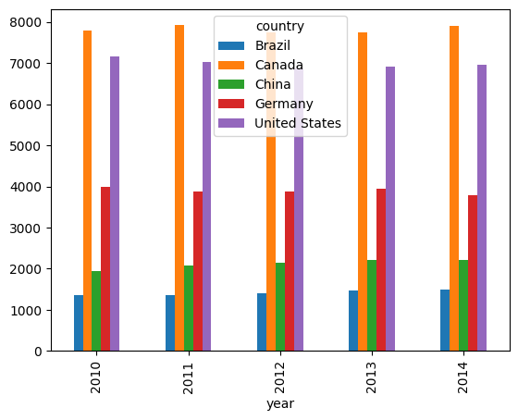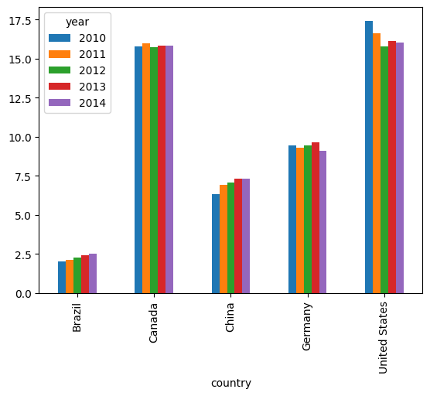

**The first chart here we have plotted carbon IV emission in metrics per ton per year and we observe Canada has been leading In emission of carbon IV oxide throughout the 4 yrs from 2010 this maybe due to it having more petroleum driven engines including many cars. We also see united states is their following Canada in Carbon IV oxide emission.**

**The high Carbon IV oxide emission in this two countries can also be because of development as they are very developed they have more engines and other machinery to reduce their work load which in turn lead to more carbon IV oxide emission. Brazil is their which has the least emission we may conclude that they are less developed having less machinery hence low carbon IV oxide emission**

**When we try to check the second graph on the right we also see that The high Carbon IV oxide emission in Canada and United states may have been contributed with the high energy use as we see in the second graph this two countries have used a lot of energy.**

**We also plotted some line graphs to get the trend in CO2 emission and also in usage of energy on the 4 years**

**From the line graphs, shown below, the trend can be easily noticed how Canada and United states have**

**a high point on the left graph which shows they have been producing a lot of carbon IV oxide in the last 4 years from 2010 at constant.**

**On the right graph we see Canada high above other countries in usage of energy which explains why they emit more Carbon IV oxide they are followed by Unite states and lastly is Brazil at the bottom which also explains why they produce less Carbon IV per year.**

**We plotted a correlation map of Carbon IV emission and Energy usage.**

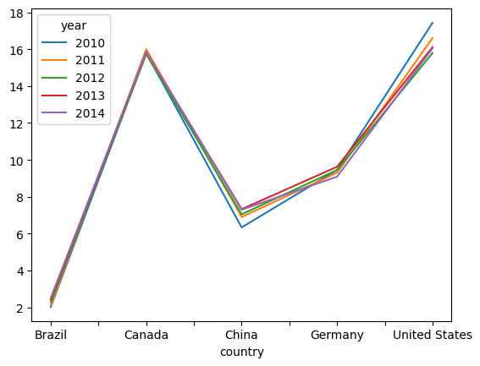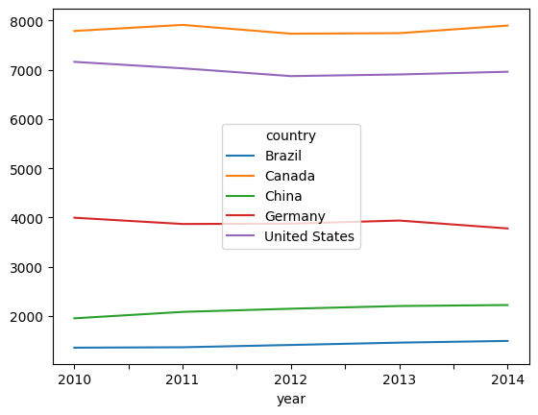

|  | metric tons of CO2 per capita | Energy use (kg of oil equivalent) per capita |
| --- | --- | --- |
| metric tons of CO2 per capita | 1.000000 | 0.971222 |
| Energy use (kg of oil equivalent) per capita | 0.971222 | 1.000000 |

**From the correlation table we see that the two are highly positively correlated hence the energy usage affects the total carbon IV oxide emission.**